How To | Posting an Exam in Elentra

Introduction:
This How-to guide will demonstrate how to post an Exam in the Elentra LMS as an Admin or Superuser.

How to:
- To begin creating and posting an exam, from the Elentra Dashboard navigate to Admin and click on Manage Exams on the drop-down menu.
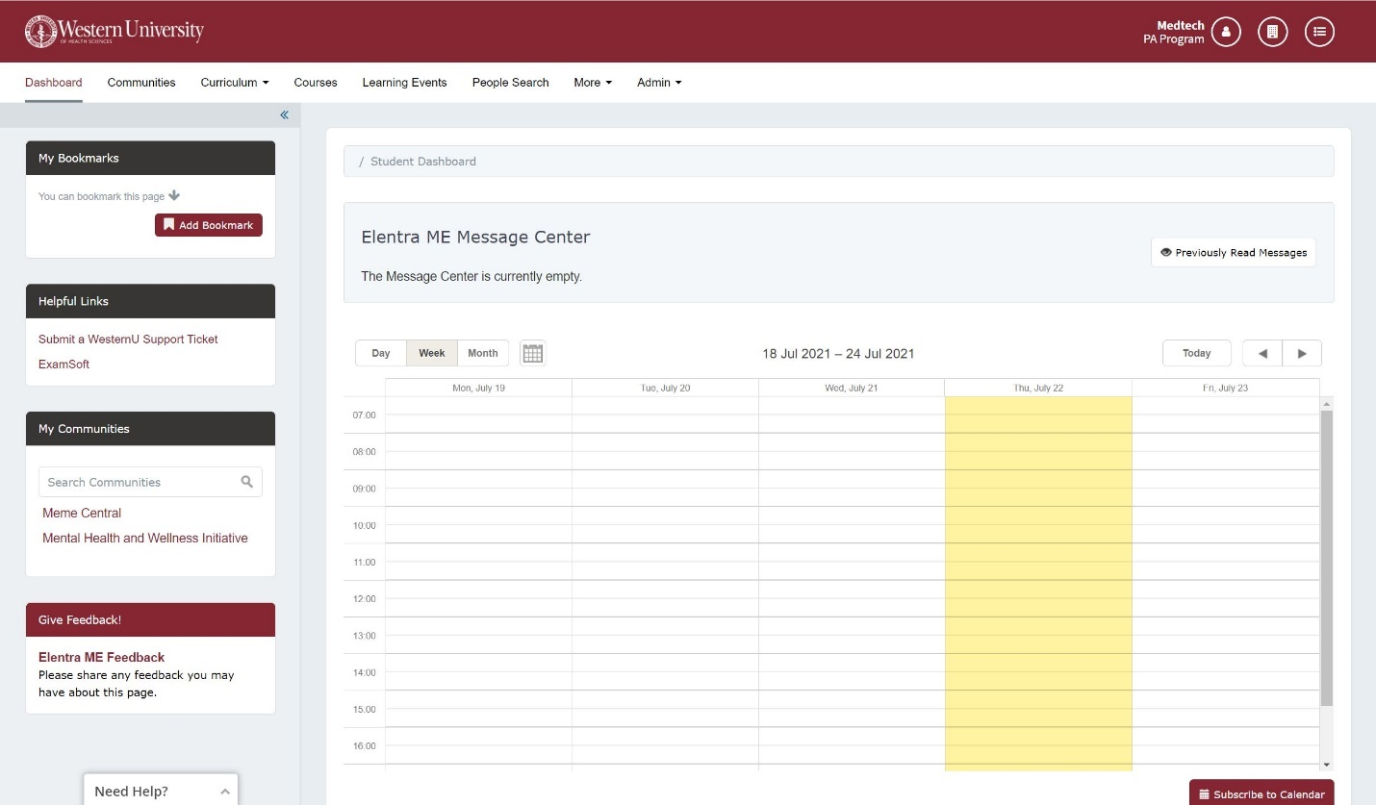

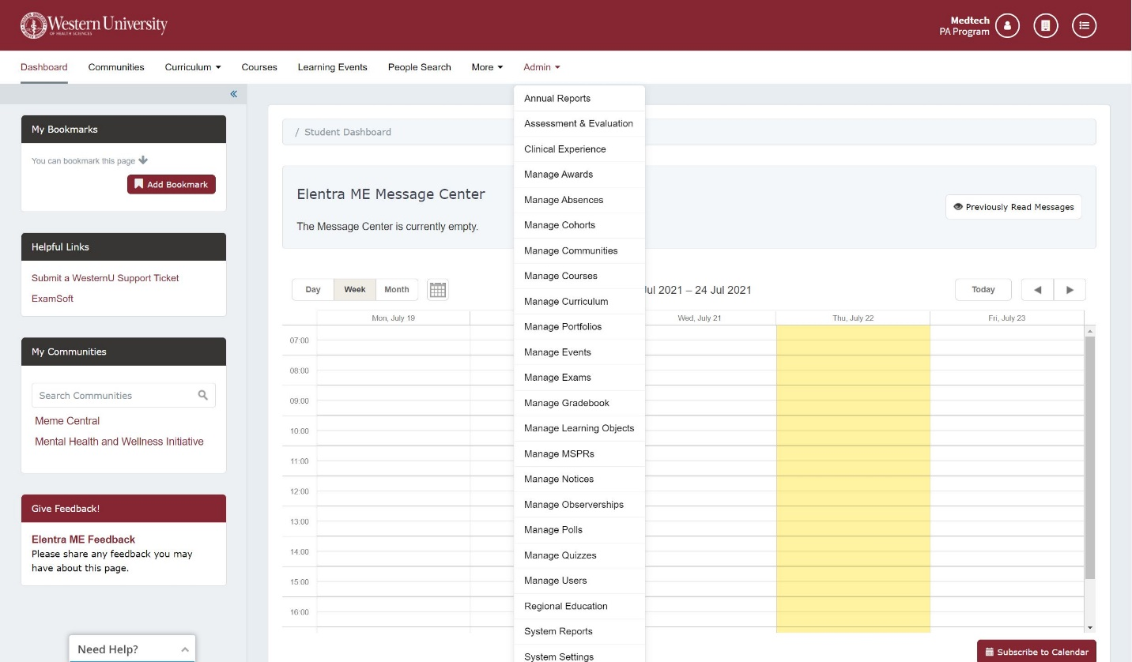
- You will now be on the Exam Dashboard 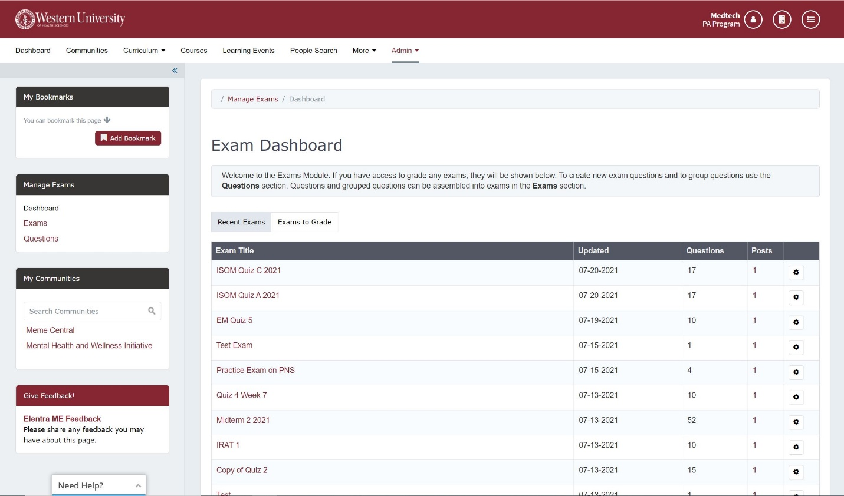

- On the left-hand side you will find the Manage Exams menu. Here you will have three options to click on.
- Dashboard – this is an overview of all exams posted.
- Exams – this will navigate you to a list of Exam folders and list of posted exams.
- Questions – this will navigate you to the question bank.
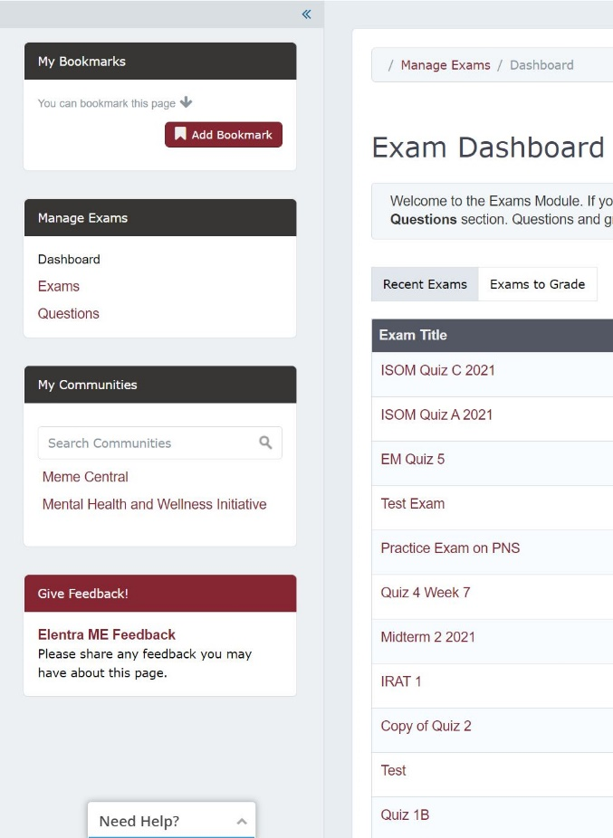
To create and post an exam on the Exam Dashboard click on Exams in the left-hand menu.
- You will now see a list of folders designated by course. These folders contain the exams/quizzes for that course.
- For example, if you click on PA5041 – HPDP 2 it will take them to a list of Exams/Quizzes for that course as depicted in the screenshot.
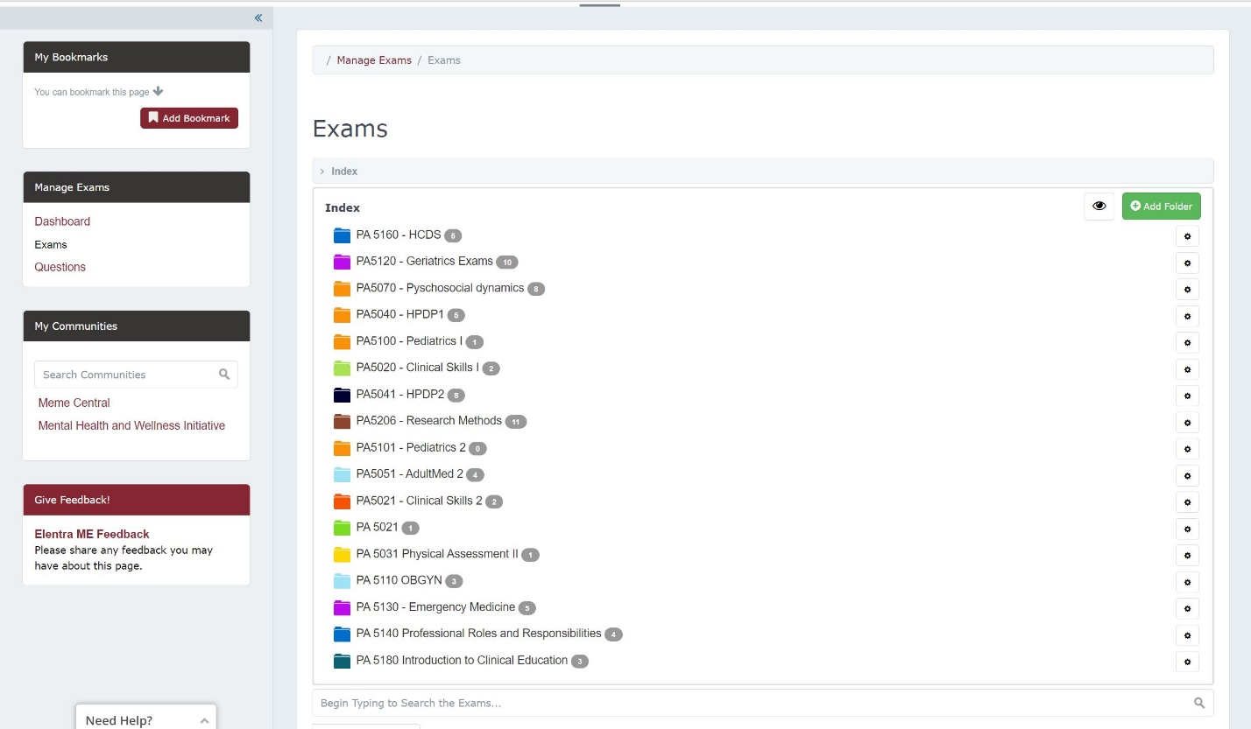
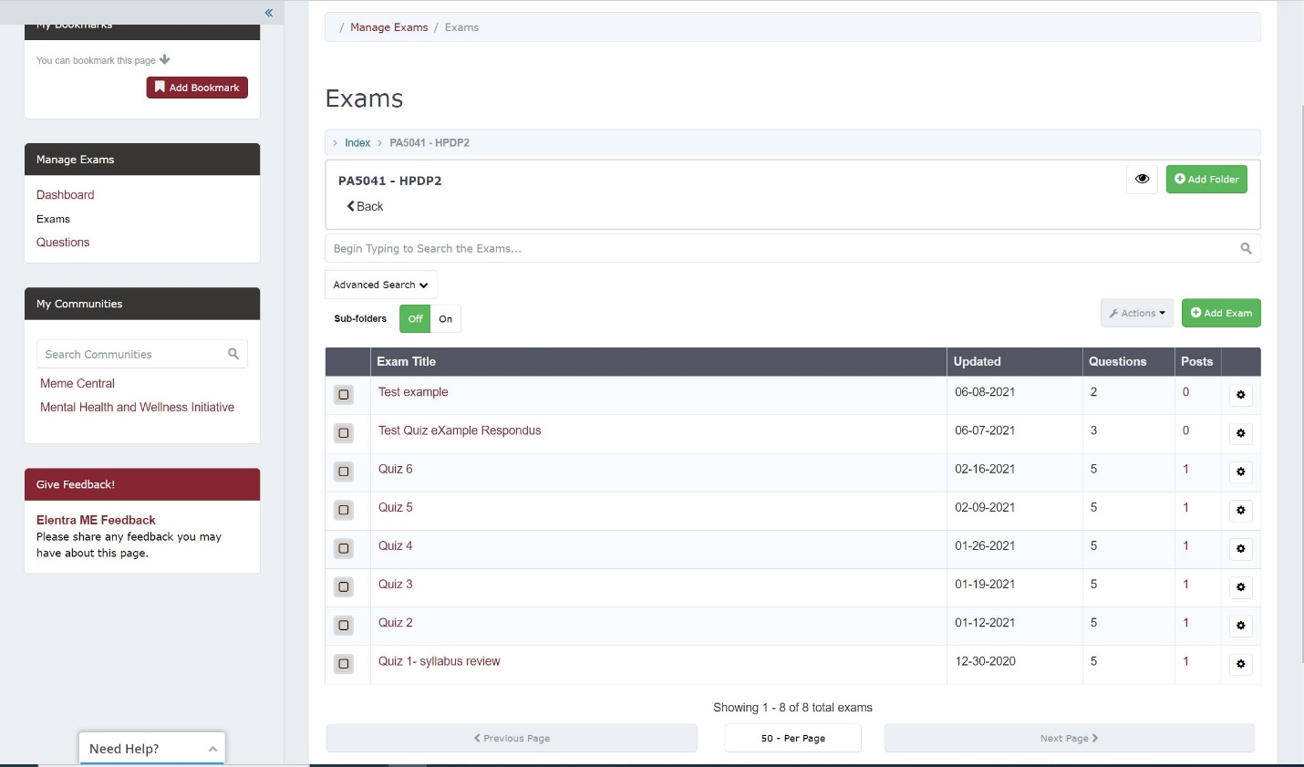

- To add a new Exam, click on the green button Add Exam.
- A pop up will appear on screen.
- You must enter a title for the Exam as well as select a folder to place then exam.

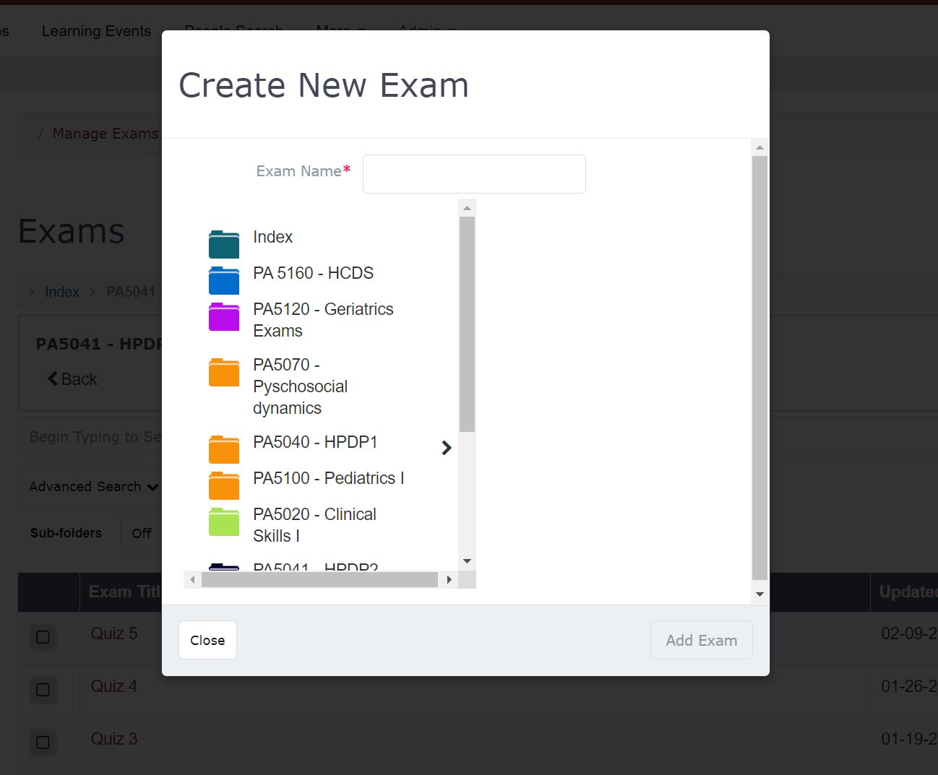
- After you create a title and selects a folder you will be taken to a new screen where you to will now complete the steps to Post the Exam.

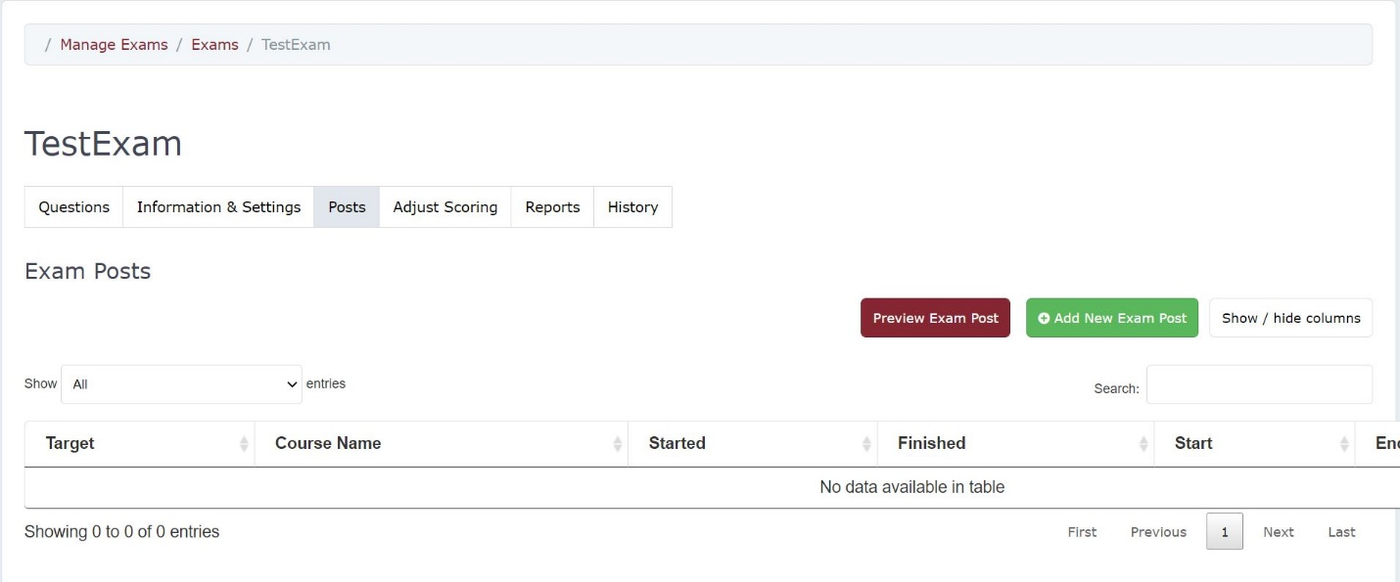
- Click on “Add New Exam Post”
- This will take you to the Exam section where they will attach the Exam Post to a Learning Event and enter any exam description or instructions.
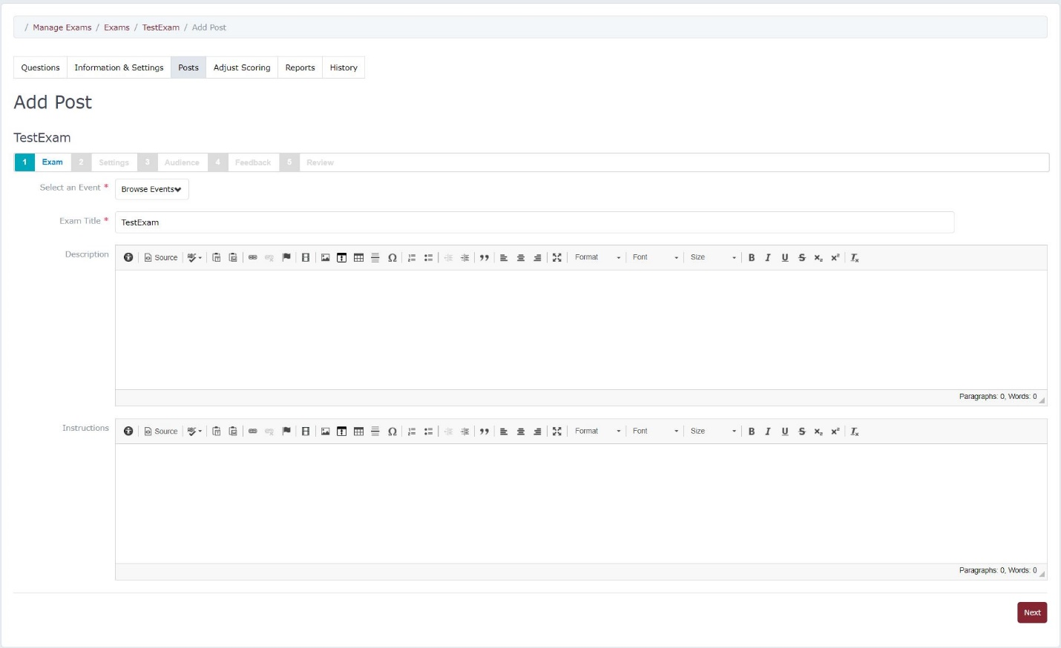
- After entering the required information click Next.
This will take you to Settings Tab.
- The Settings Tab is where you will enter the exam settings such as Start Date and Time as well as Exam Security and how many attempts students will have.
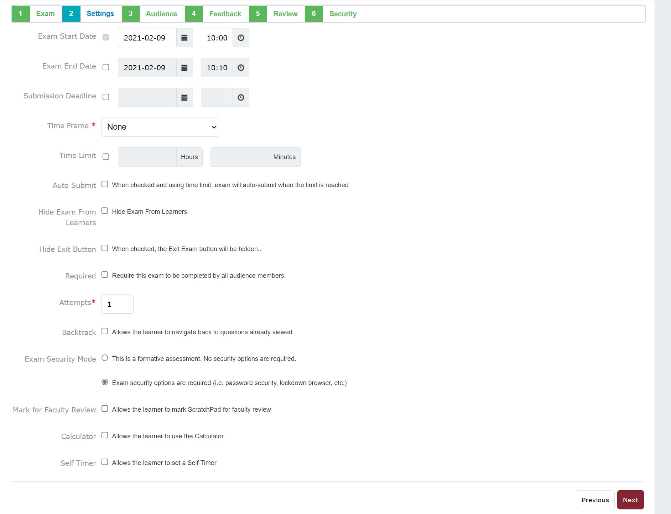
- Exam Start and End Date: Enter a Start and End date for the exam to be available as needed.
- Submission Deadline: This is an optional feature. If you set this, exams must be submitted by this time.
  - If you have set an End Date and no Submission Deadline, learners can resume an exam they have already started after the End Date via the link on their view of the learning event and submit it; however, the exam will no longer be visible on their Unsubmitted Exams tab. They will not be able to begin a new attempt after the End Date.
  - If the learner submits after the End Date, their submission date and time will be highlighted in red font in the View Activity sub-tab of the Exam Post.
  - If you apply a Submission Deadline and no End Date, once the Submission Deadline has passed, learners cannot resume an already started exam or begin a new attempt through their view of the Learning Event. The Resume button will be greyed out. The exam will no longer be visible on their Unsubmitted Exams tab.
  - If the learner tries to open the exam through the Learning Event tab after the submission deadline, they will be able to but will be prevented from starting the exam.
- Time Frame: This determines where the exam will display in the resources section of a learning event page.
- Time Limit: This allows you to limit the length of time a learner has to complete the exam (e.g., 60 minutes). Enabling this feature will also make a Time Left counter appear to learners during an exam.
- Auto Submit: If using a time limit, you can also use the auto-submit feature so that the exam is automatically submitted when the time expires, assuming the learner is still active in the exam.
- Hide Exam From Learners: If you hide the exam, you’ll be able to save the post, but learners won’t be able to see the post as a resource on the associated learning event and won't see the exam in their My Exams list. To make the exam visible to learners, you are required to return to the post, uncheck this box, and then save the post.
- Required: Click the box to make this exam required.
- Attempts: Adjust this if you’d like students to be able to complete the exam more than once.
- Backtrack: Enable this if you want learners to be able to view questions already completed.
- Exam Security Mode: Apply as needed. If you apply this, the wizard will require you to complete Step 6: Security after completing the other steps.
- Mark for Faculty Review: Enable this to allow students to make notes during the exam and mark them as viewable by faculty. Note that students cannot add comments once an exam has been submitted.
- Calculator: Enable this to allow students access to an inline calculator during the exam.
- Self Timer: Enable this to allow the learner to set a timer for him/herself during the exam.

- Click Next Step.

- After clicking Next Step user will be taken to the Audience tab.

The Audience tab shows the list of students attached to the Learning Event and who will be taking the exam.
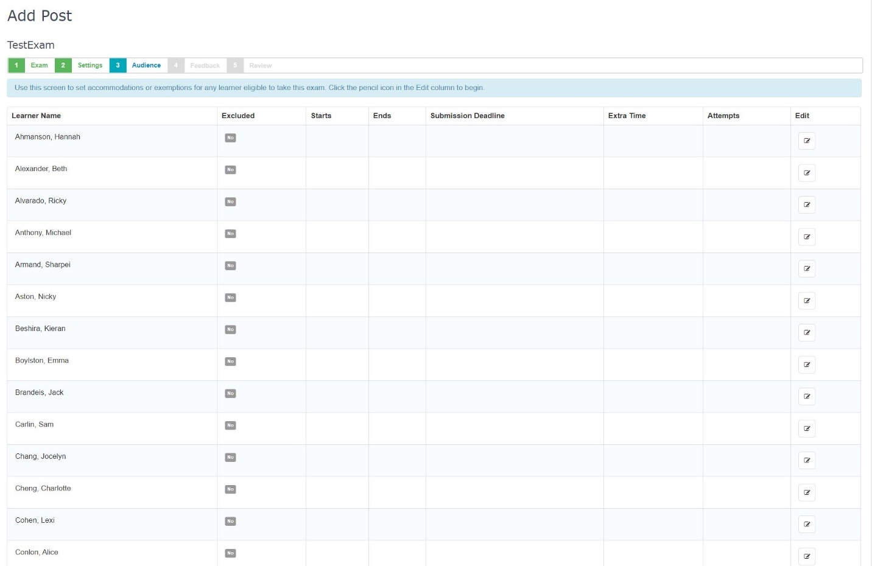
- Clicking on the pencil icon under the Edit tab will open a new menu where you can set accommodations for a particular student.
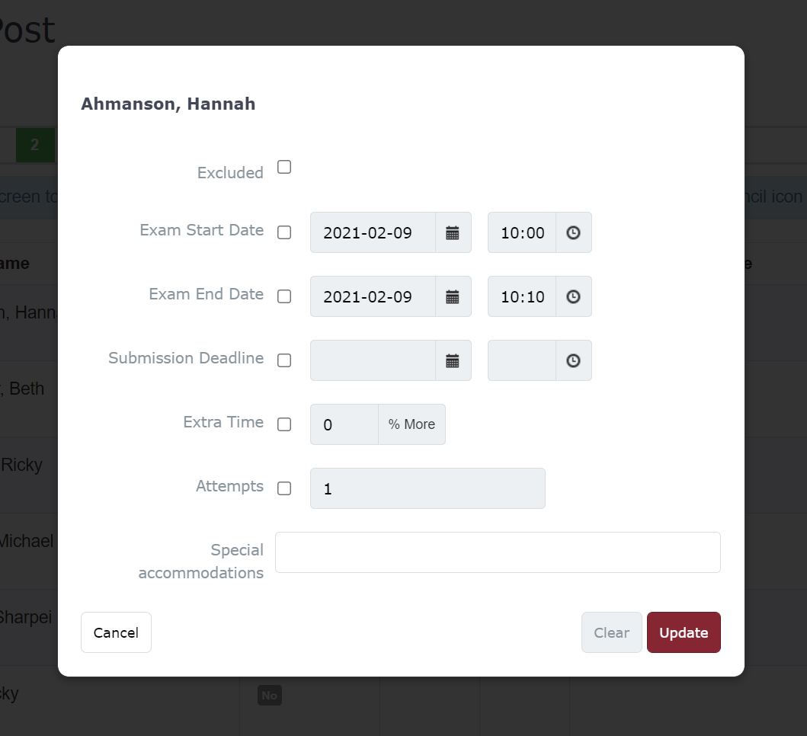
- Excluded: Clicking this checkbox will exclude the learner from the exam audience.
- Exam Start and End Date: Click this and provide modified dates to change when a learner can access the exam.
- Submission Deadline: Click this and provide a new deadline to change the deadline for a learner.
- Extra Time: Click this and enter a percentage increase in time for the learner to complete the exam.
- Max Attempts: Click this and enter a modified number of exams attempts for the learner.

- Click Update. After clicking Update you will be taken back to the Audience tab.
- Click Next to continue to the Feedback tab.

- The Feedback tab is where you will set if and when any feedback will be released to students as well as when grades will be available to them as well.
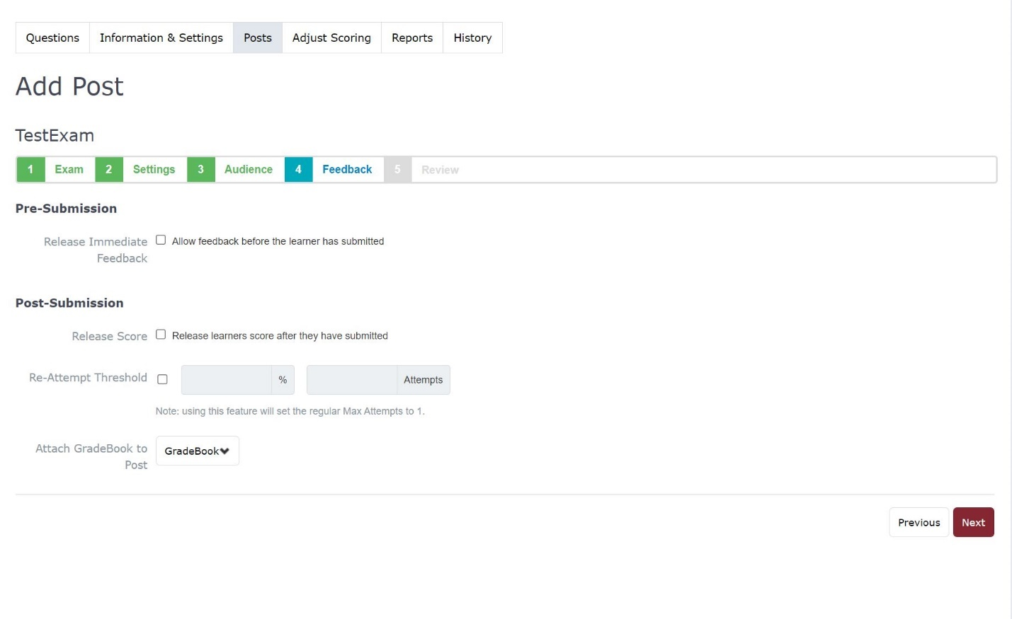
- Pre-Submission Feedback
- This tool allows you to create an exam post those learners can use to get immediate feedback on questions while they complete them and without submitting an exam.
- Post-Submission Feedback
- Release Score: click this to return scores to learners after they submit an exam.
- Release Feedback: This will show learners the questions that they answered correctly and incorrectly and access the information stored in the rationale section of the exam items when they get their scores.
- Release Start and End Dates: Set the release start and end dates to delay the release of scores and/or feedback if required.
- Re-Attempt Threshold: Set a minimum score to merit completeness, then set an allowable number of attempts to attain the minimum score. E.g., you can specify that a learner must achieve 80% on this exam and has two attempts to do so. If the learner scores 50% on their first attempt, the system will automatically let them take the exam once more.
- Attach Gradebook: Select an existing Gradebook entry to attach the exam to in the Gradebook.
Click “Next”
The Review tab shows a list of options that were selected for the entire exam.
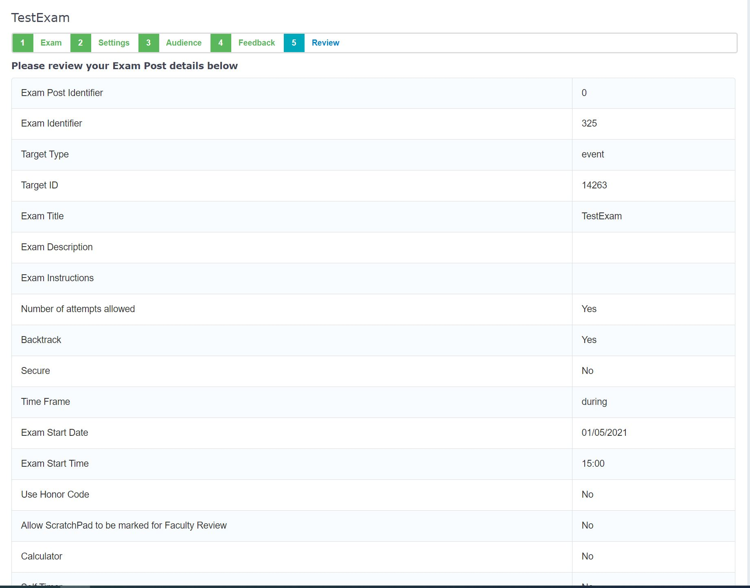
- Click Save and Continue.
- If you enable a lockdown browser in the Settings tab there will be a sixth tab titled Security. This new tab will allow to set the lockdown browser.

- The Security tab will give you a list of security options. Elentra currently only supports the Respondus LockDown Browser for the installation at WesternU.
- Be sure to select the last option, Respondus LockDown Browser.

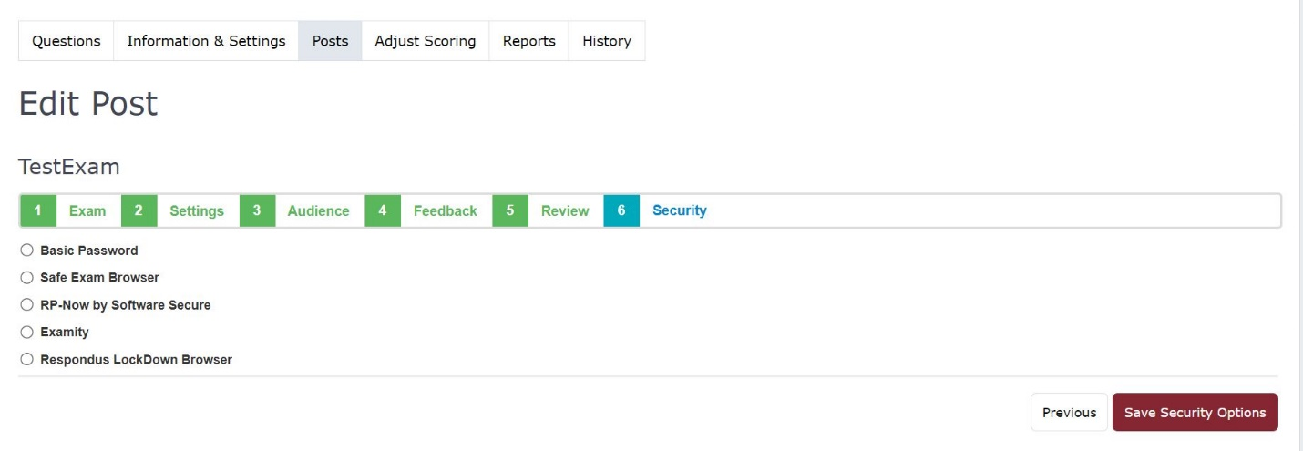
- Click Save Security Options.
- You will receive a message stating that the Exam has been posted.

Gradebook

Creating an Assessment in the Gradebook
- On the Elentra dashboard navigate to Admin -> Manage Gradebook.
- You will see a list of courses that you are currently teaching or attached to. Select the appropriate course. You will now see an overview of the gradebook.
- To create a new Assessment, click on the Add New Assessment button that is highlighted in the image below.
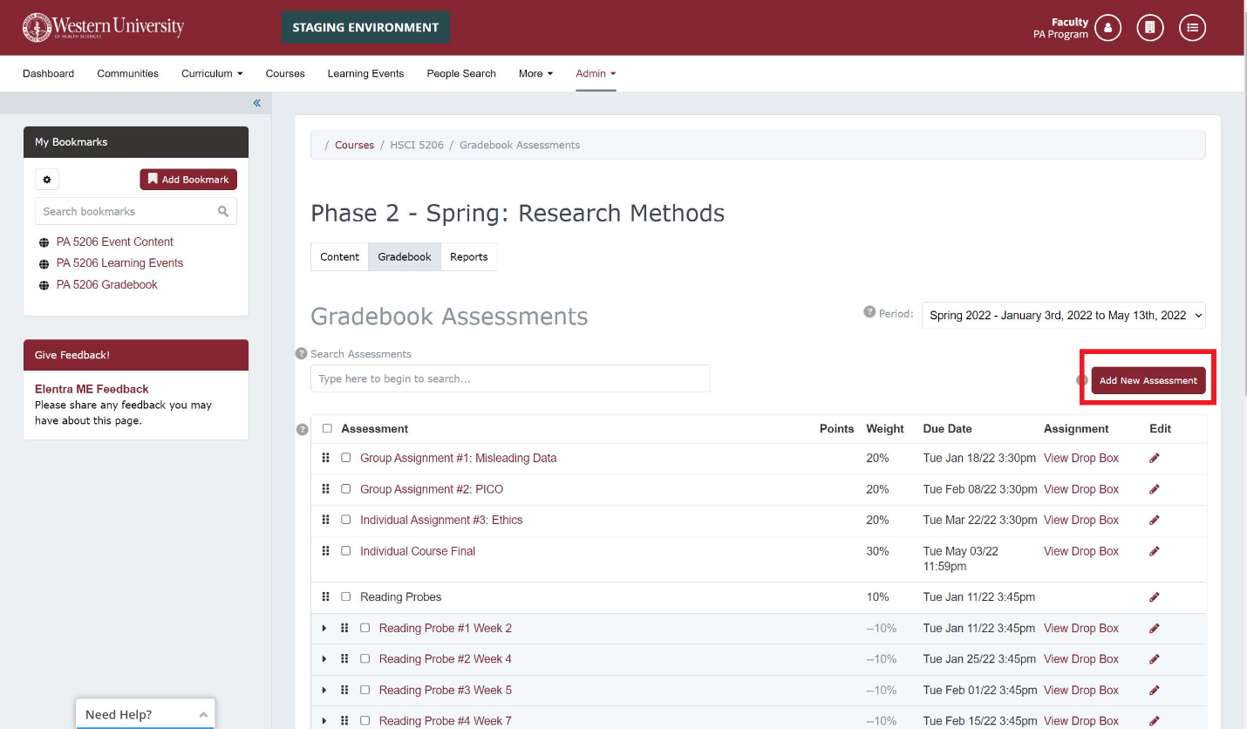
- Once clicked you will now be able to create an Assessment.
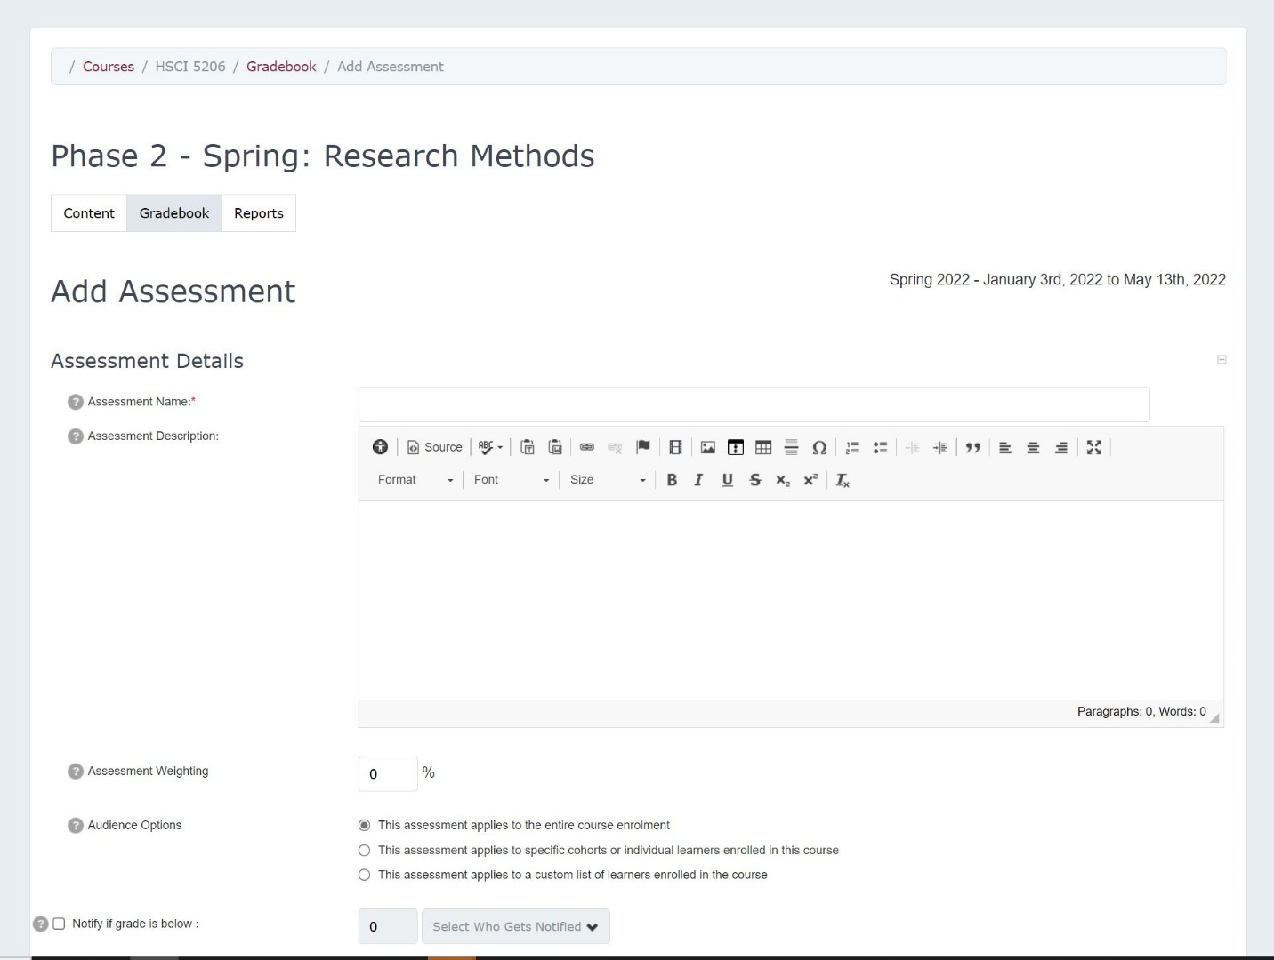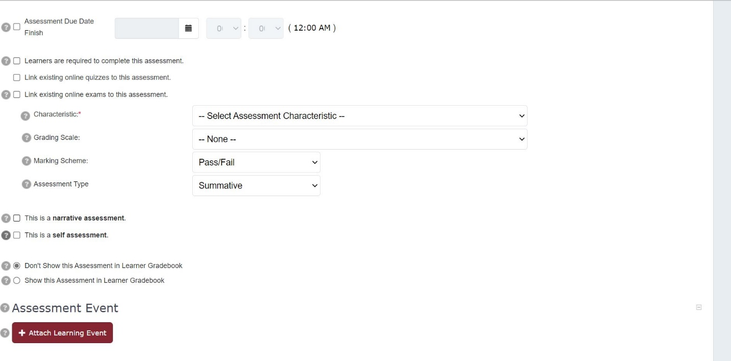
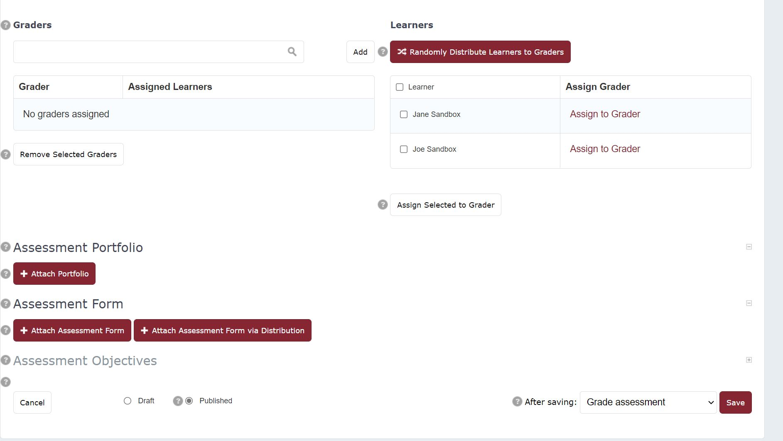

Assessment Details Section
- Assessment Name: This is a required field and will display to learners and any graders associated with this assessment.
- Assessment Description: This is an optional field. The description will display on the edit assessment screen and will be seen by learners when reviewing or submitting an assignment through a dropbox, if one is associated with the assessment.
- Assessment Weighting: This can be left as 0% if an assessment carries no weight towards the final course grade.
- Audience Options: Use this optional field to assign an assessment to the entire course enrolment, one or more course groups, one or more specific cohorts, or individuals in the course, or a custom list of learners.
- Notify if grade is below: Use this feature to automatically send an email to the selected audience if learners score below the designated threshold.
- Assessment Due Date: This is not a required field, but will create a due date visible to learners if used. If the assessment later has a dropbox added to it, the dropbox assignment will inherit the assessment due date.
- Learners are required to complete this assessment: This creates a flag in the database for this assessment but does not impact the learner's experience.
- Link existing online exams: See details on the Gradebook > Attach Exam lesson of this guide.
- Characteristic: This is an assessment type (test, paper, oral exam, etc.) and is a required field.
- Grading Scale: Optionally, set a grading scale for an assessment. If a grading scale is used, you can control how the learner will view their results (e.g., see the grading scale, marking scheme, both).
- Marking Scheme: Elentra supports Pass/Fail, Percentage, Numeric, Complete/Incomplete, and Floating Numeric marking schemes.
- Assessment Type: Formative and Summative are the options.
- Typically, formative assessment is to monitor student learning and provide ongoing feedback, and summative assessment captures overall student learning at the end of an instructional unit. You may wish to check with your institution’s Student Assessment Coordinator or Educational Consultant to clarify how your institution uses these terms. The number of formative and summative assessments in a course is reported by course in the Assessment Summary Report.
- Narrative assessment: Check this off if students receive written feedback for this assessment. This information is reported by course in the Assessment Summary Report.
- Self-assessment: Check this off if students are assessing themselves.
- Assessment Visibility:
- If you select “Don’t Show this Assessment in the Learner Gradebook” learners will not see the assessment nor their grade until you change the permission. This can be useful if you’d like to enter grades but need approval from someone before the grades can be made visible to students.
- If you select “Show this Assessment in the Learner Gradebook”, you should set the appropriate start and end times. Students will be able to see the assessment and their grade in their Gradebook during the active date range. If you enter grades after the designated start time, students will see their grades immediately when you save your work.
- Note that a green checkmark will be visible to the right of the assessment when viewing a list of assessments in a course Gradebook, so that you can easily tell which assessments have been made visible to learners.
- Choose how to display grades to the learner. Optionally select to show them the marking scheme, grading scale, or both.
- Assessment Graders: This allows you to grant grading access to specific faculty or learners designated as TAs for a course so they can view assignments and enter assessment grades for their assigned learners. First, you add graders to the list, then you assign learners to the graders.

Creating a Drop Box in Elentra
A Drop Box is used if the faculty wish to have students submit a document for grading. The following steps will walk users through creating a Drop Box for the assignment.
- From the Dashboard, navigate to Admin and in the dropdown, menu select Manage Gradebook
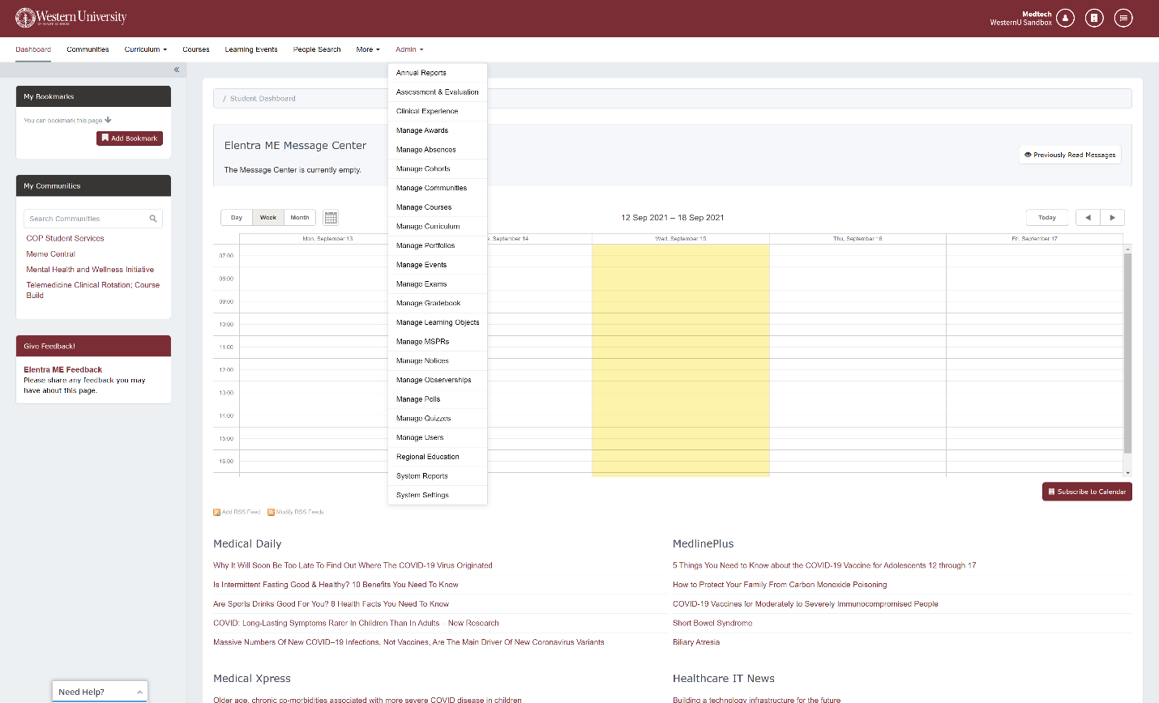
- Manage Gradebook will now display a list of courses and their gradebook.

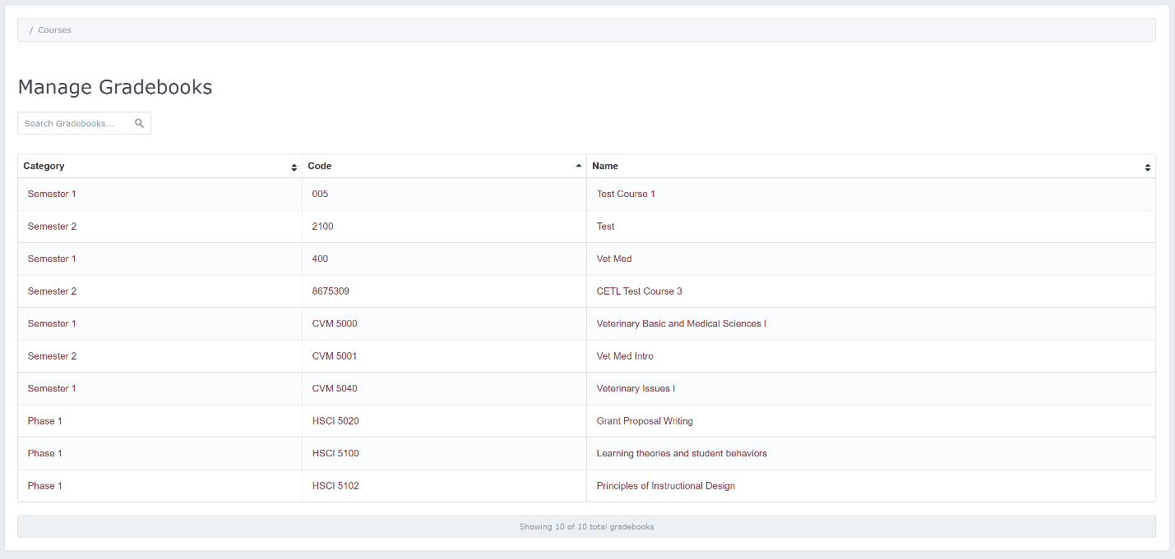
- Click on the course you would like to add a Drop Box to and you will be taken to the course gradebook.

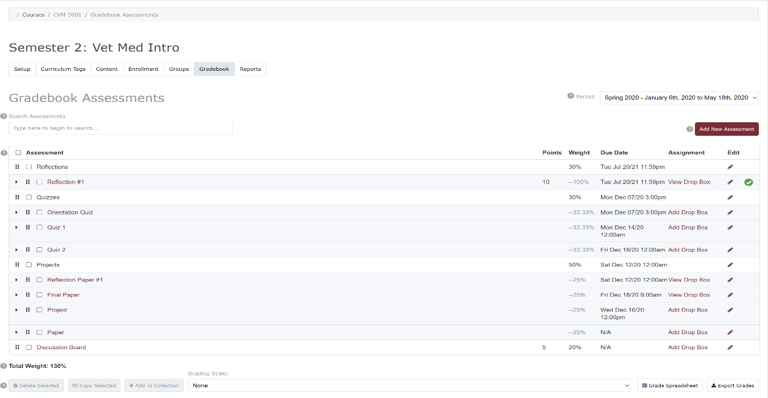
- Select the assessment/assignment you would like to add a Drop Box to and click Add Drop Box

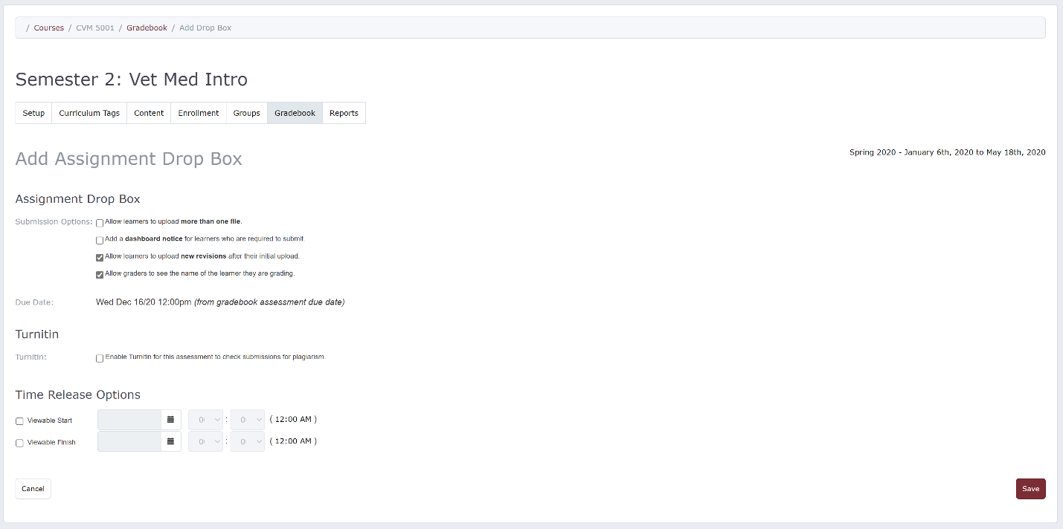
You will now find a list of settings you can enable or disable.
- Submission Options:
- Allow Learners to upload more than one file: can be useful if students are submitting pictures or documentation of an experience. The maximum number of files a student can upload also limits how many files can be handed back.
- Add a dashboard notice for learners: this will generate a Dashboard notice, including the assessment due date and a link to the drop box, and display it to the learners responsible for the assessment.
- Allow Learners to upload revisions: will allow students to replace an existing file with a newer one.
- Allow graders to see the names of learners they are grading: can be unchecked if you wish graders to work without knowing learners' identities.
- Submission due date: If you have set an assessment due date, the submission due date for the drop box will match it. If you change the assessment due date, the assignment submission due date will automatically be adjusted.
- Turnitin: If your institution has an agreement with Turnitin and is using Elentra's Turnitin integration, you can optionally add additional settings to your drop box.
- Time Release Options: Set the time release for a Viewable Start and Finish, which will control when the drop box will be visible to users. The default setting causes the drop box to be immediately visible to learners and does not set finish date. This setting does not impact the visibility Dashboard notice; it only impacts the availability of the link to upload the assignment in the learner's My Assignments listing.
- Click Save.
How to Release Grades
- Navigate to Admin -> Gradebook
- Once in the gradebook select the assessment (the pencil icon)
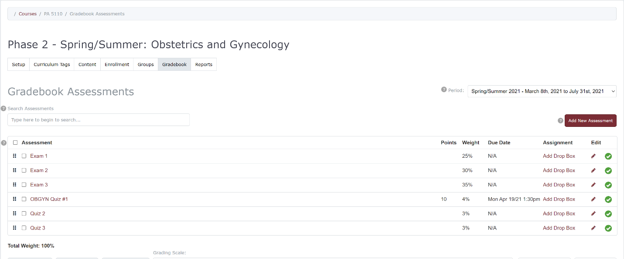
- Once you’re in the editing portion of the assessment. Scroll down to the highlighted section. Select the second box: Show this assessment in Learner Gradebook. This will release the grades to the students.
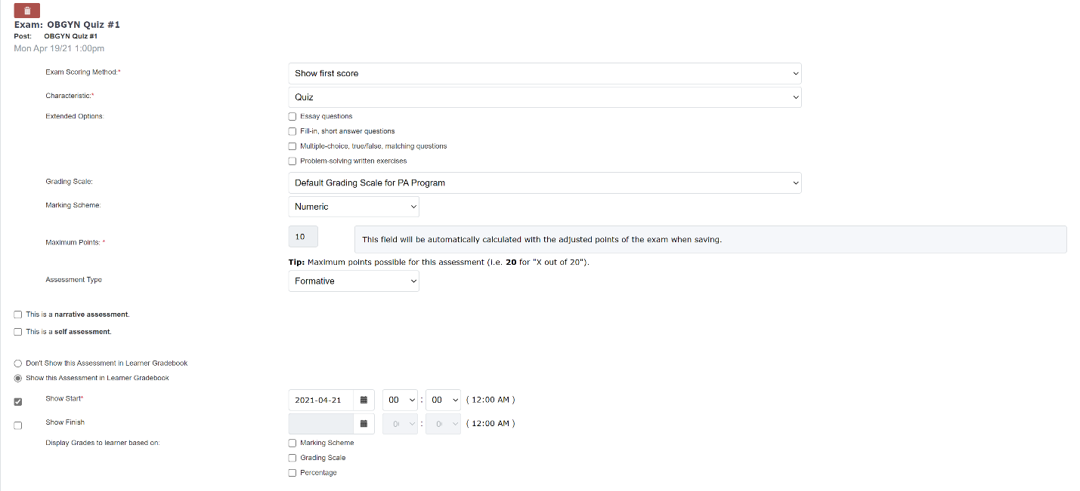
- Click Save.

