- Once in the Exam section of Elentra navigate to the Question Bank and select the correct folder.
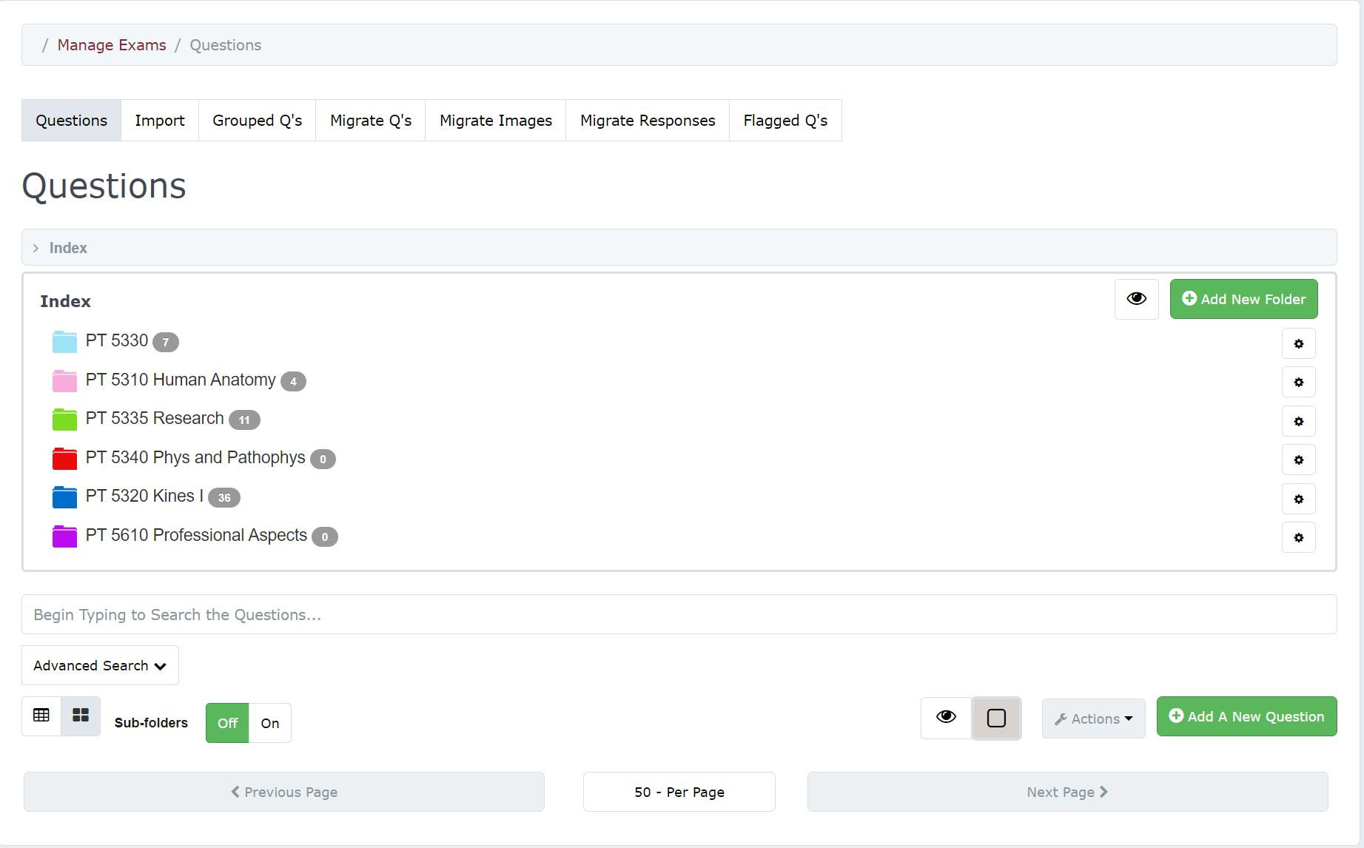
- Next click on the Gear icon next to the folder and select Edit & Manage Authors
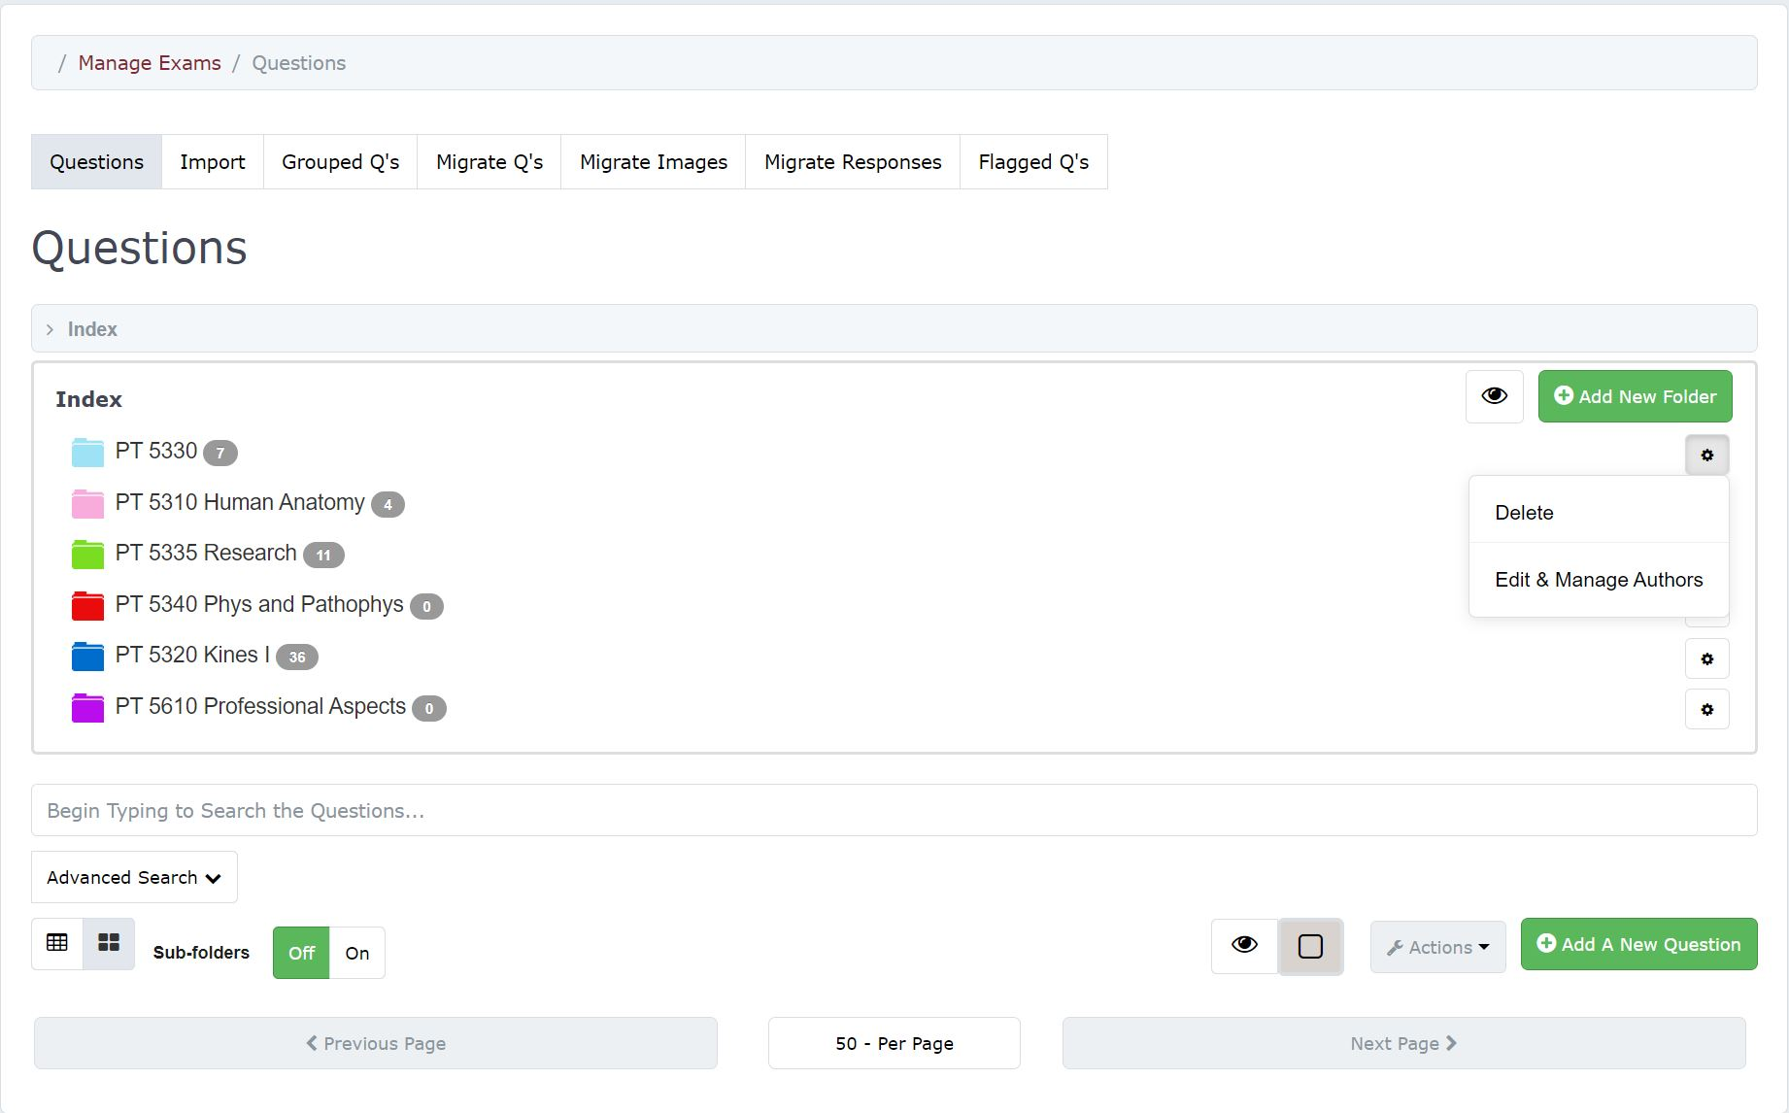
- Now you can add an additional user by searching their name in the search box and clicking SAVE. After that you have successfully added permission to the folder and questions inside.
