An Overview of Student Learning Styles: Which One Should I Use?

Coffield et al. (2004). Learning styles a pedagogy in post-16 learning: A systematic and critical review. London. Learning Skills and Research Center. 174 pages. 72 learning styles theories divided into 5 families.
Pashler, H., McDaniel, M., Rohrer, D., & Bjork, R. (2008). Learning styles: Concepts and evidence. Psychological Science in the Public Interest, 9(3), 106-119.
What do you think a learning style is? (definition in 25 words or less)

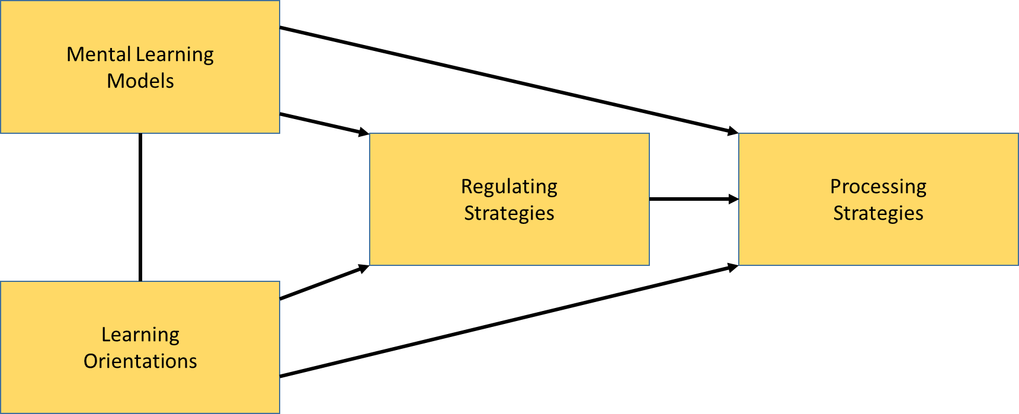

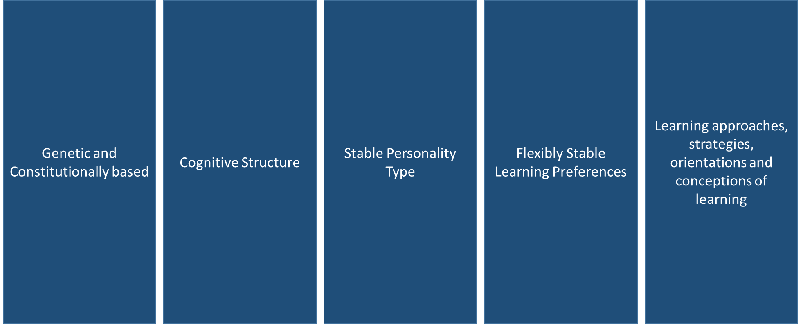
Family #1 -
Examples

Family #2
Examples

Family #3

Family #4

Family #5

Meshing Hypothesis: (Definition)

TRUE FALSE

Two Free student learning styles inventories:
VARK – visual – auditory – read/write – kinesthetic:
www.Vark-learn.com free inventory 16 questions. Somewhat validated. Study strategies included for students.
Learning family:

Grasha-Reichman Student Learning Style inventory. Online with automatic calculation. 60 questions.
http://longleaf.net/learningstyle.html
or Google search terms: grasha reichman learning style longleaf
Learning family:

FREE BONUS:
Grasha Teaching Style online survey:
http://longleaf.net/teachingstyle.html
or Google search terms: grasha teaching style longleaf

Free PDF of Teaching with Style
https://ltc.highline.edu/CR/Teaching%20with%20Style%20-%20Understanding%20Teaching%20&%20Learning%20Styles%20-%20Grasha.pdf
or look on Blackboard for PDF along with Coffield et al.

